**RIPHAH INTERNATIONAL UNIVERSITY, ISLAMABAD**



**Lab # 3**

**Bachelors of Computer Science – 6th Semester**

**Subject: Operating System**

**Submitted to: Ms. Kausar**

**Submitted by: Nimra Ashfaq-40852**

**Date of Submission: 08- Sep -2024**

**QUESTION:1**

* Start by creating a directories named **books**.

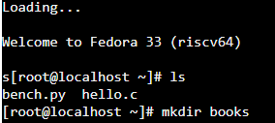

* After creating a directory create three directries in it named **math** ,**physics** ,**computer**.

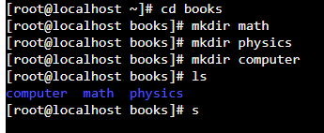

* Within math directory ,create two more directories **trignometry** and **calculas**.

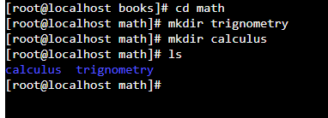

* Go into the **physics** directory and create three directories named **quantum, classical, nuclear**.

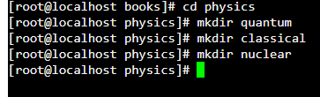

**QUESTION: 2**

**Linux Directory Commands**

* **pwd** (Print Working Directory):

Shows the path of the current directory you are in.



* **ls** (List show):

show all the contents of a directory. It’s like opening a folder to see what files and subdirectories are inside.



* **mkdir** (make directory):

It’s like creating a new folder in your file system.



* **rmdir** (remove directory):

Deletes an empty directory.

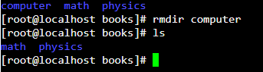

* **rm –r** (Remove recursively):

Deletes a directory and its contents.

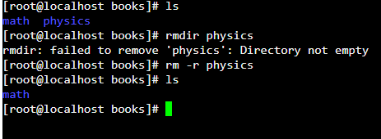

* **cd**(change directory):

It’s like moving into a different folder.



**BASH**

BASH, or **Bourne Again Shell**, is a command-line interface used to interact with the operating system through text-based commands. It allows users to manage files, run programs, and automate tasks using scripts

**QUESTION: 3**

* Start by creating a directories named **d1**.

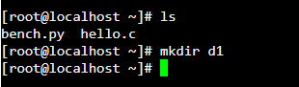

* After creating a directory create four directories in it named **d11, d12, d13, d14**.

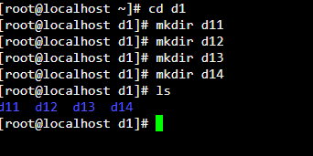

* Within **d11** directory , create three files name **f1, f2** and **f3**.

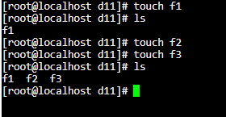

* Go into the **d12** directory and create a file named **f4.**

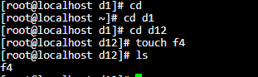

* Then Go into the **d13** directory and create two files named **f5 and f6.**

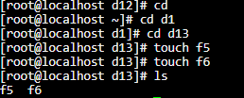

* Know Go into the **d14** directory and create three files named **f7, f8 and f9.**

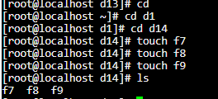

**QUESTION: 4**

* Start by creating a directories named **d1**.



* After creating a directory d1 create four directories in it named **d11,d12,d13,d14**.

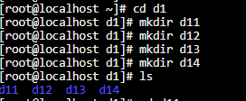

* Within **d11** directory, create two files name **f1** and **f2**.

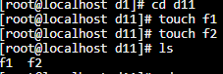

* Go into the **d12** directory and create a file named **f3**.

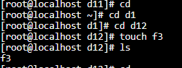

* Then Go into the **d13** directory and create two files named **f4 and f5.**

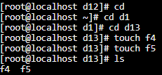

* Know Go into the **d14** directory and create a directory named **f6.**

